

SIMATS ENGINEERING

Saveetha Institute of Medical and Technical Sciences
Chennai- 602105

Student Name: Samuel V Reg. No: 192412237
Course Code:CSA-0714 Slot: A
Course Name: Computer Networks
Course Faculty: DR .P.Jesu Jayarin.
Project Title: Interactive Performance Modeling of Priority-Aware Enterprise Networks
Module Photographs: (3 photographs –Module Photo, Individual student contribution module work in the project and presentation image)
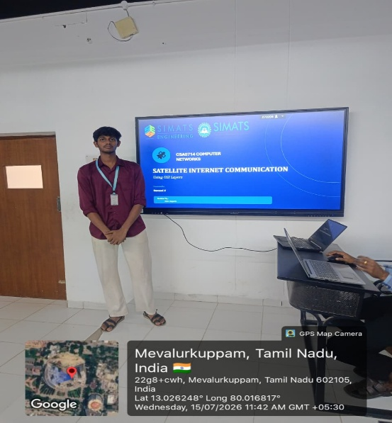
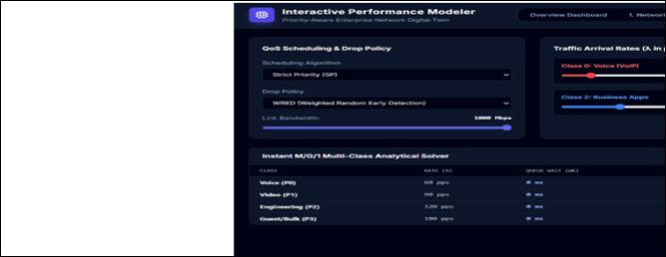

Project Description: (here you write what you did in this project (contribution) including Model Description
- Designs a secure enterprise network using VLAN segmentation to isolate departments and users.
- Configures VLANs and assigns devices to appropriate network segments, improving security and traffic management.
- Implements priority-aware traffic management to support critical applications during network congestion.
- Monitors bandwidth, latency, packet loss, and throughput to identify network performance issues.
- Provides an interactive model to analyze traffic and optimize enterprise network performance

Student Signature Guide Signature

